FOR RECEPTION USE ONLY |  | FOR RECEPTION USE ONLY
EMIS NUMBER: |  | Family members
REGISTERED GP: |  | Appointment booked with GP
PHOTO ID VERFIED:
PROOF OF ADDRESS: |  | ADULT REGISTRATION FORM
PAVILION SURGERY
2-3 Old Steine,
Brighton,
BN1 1EJ
https://www.pavilionsurgery.co.uk/
Supplying this information gives consent for us to contact you where medically
necessary
Please confirm we have your permission to telephone, text or email you regarding your direct care (please circle):
YES NO
Title:
( Mr, Miss, Mrs, Ms, Mx, Dr, other)

Name:
Date of Birth
Sex assigned at birth:  We ask for your assigned sex to help us screen for sex- specific diseases such as cervical/prostate cancer |  |  | Male  Female  Prefer not to say
Do you identify with a different gender to your birth gender?  Pronouns: |  |  | Yes / No  Eg. She/her, They/them, He/Him
Asian British | Mixed White & Asian | Other :
Black African | Mixed white & Black African | Prefer Not to Say
Black British | Mixed white & Black Caribean | White Other
Black Caribbean | Other Asian Background | White British
Ethnicity

Height
Weight
Family History:

Do you have any illnesses in your family?
Such as cancer, heart disease, diabetes, ect.

Please include family member & health condition

Allergies/side effects:

(Such as allergic reactions to medications, bee stings, foods, etc..)
Do you have, or have you had, any  serious health problems (including operations) or long term conditions?  If YES please include details & dates: | Yes/No
Do you consider yourself to have a disability:  If YES please give brief details |  |  | Yes/ No/ Prefer not to say
Smoking status:  If YES, how many per day:  If EX SMOKER, when did you quit: |  |  | Yes / No / Ex-smoker  ( We offer Smoking Cessation appointments with our nurses)

Are you being prescribed medication? |  |  YES   NO , Please skip this page
Medication For example: Aspirin | Dose  For Example: 75mg once daily |  | Reason for medication For Example: “I had a stroke”
Which pharmacy would you like your prescriptions sent to:
Please book a face to face appointment with your new doctor before you ask for any prescriptions or medications.

If you are going to run out of medication, ask your previous GP surgery for a prescription.

Please note we prescribe according to national guidelines.

Painkillers including Gabapentin and Pregabalin
We do not prescribe opiates or gabapentinoids for long term pain. This includes codeine, tramadol, zapain, dihydrocodeine, gabapentin and pregabalin. If you are taking these drugs for long term pain, we will prescribe a reducing course of these drugs and stop them.

Sleeping tablets.
We do not prescribe long term benzodiazepines for sleep problems.
This includes zopiclone, zolpidem and temazepam.
If you are taking these drugs, we will prescribe a reducing course of these drugs and stop them.

Benzodiazepines
We do not prescribe long term benzodiazepines. This includes diazepam. If you are taking these drugs, we will prescribe a reducing course of these drugs and stop them.

Please sign here to say you have read and understood this page

Signature _________________________ Name _______________ Date ______

What is your main spoken language:
Do you have any special communication requirements:

(Eg. Use of interpreter, receiving letters in large print, ect)

Summary Care Record  A Summary Care Record is used in Emergency Care. It  contains information about  your medicines, allergies & bad reactions to drugs to ensure  your carers have enough information to treat you safely. | Your Summary Care Record will be available to  Authorised staff providing your care in England & will ask permission to look at it.  Should there be an accident or illness Healthcare  Staff will have immediate access to important information about your health.  A Summary Care Record will automatically be created for you unless you wish to opt out.  If you do wish to opt out, please indicate here:  Opt OUT  
This will help medical staff care for you properly, and respect your choices, when you need care away from your GP practice. This is because having more information on
your SCR means they will have a better understanding of your needs and preferences.
When you are treated away from your usual doctor's surgery, the health care staff there can't see your GP medical records. Looking at your SCR can speed up your care and make sure you are given the right medicines and treatment.
The only people who might see your Summary Care Record are registered and regulated healthcare professionals, for example doctors, nurses, paramedics, pharmacists and staff working under their direct supervision. Your Summary Care record will only be accessed so a healthcare professional can give you individual care. Staff working for organisations that do not provide direct care are not able to view your Summary Care Record.
Before accessing a Summary Care Record healthcare staff will always ask your permission to view it, unless it is a medical emergency and you are unable to give permission.

Emergency Contact details
(someone we can contact if medically necessary)
Relationship status:
e.g. Mother, Father, Spouse, friend, flat mate,...

Title And Full Name: ( Mr, Miss, Mrs, Ms, Mx, Dr, other)
Address:
Mobile Number:

Home Telephone Number:
Are they registered as a patient at Pavilion Surgery? | Yes / No
Would you like the above person to : Make appointments ?

Speak about medical records ?

Have you served in the armed forces:  If YES please provide details: |  | Yes/No
Are you a carer:  Do family, friends or neighbours rely on you because they have long-term ill health, disability or problems with old age  If YES would you like to be sent an information pack about help available to you? |  | Yes/No  Yes/No
Application for online access to my medical record (OVER 16’s ONLY)

A higher standard of documentation is needed for online registration. You will need two forms of documentation, one of which must contain a photo. Acceptable docu-
ments include passports, photo driving licences and bank statements, but not bills (see
Full Name:
Confirm Email:
Confirm Mobile:
1. I have read an understood the information leaflet provided by the practice. (Available at the ground floor reception)
2. I will be responsible for the security of the information that I see or download.
3. If I choose to share my information with anyone else, this is at my own risk.
4. I will contact the practice as soon as possible if I suspect that my account has been accessed by someone without my agreement.
5. If I see information in my record that is not about me or is inaccurate, I will contact the practice as soon as possible.
Signature: | Date:
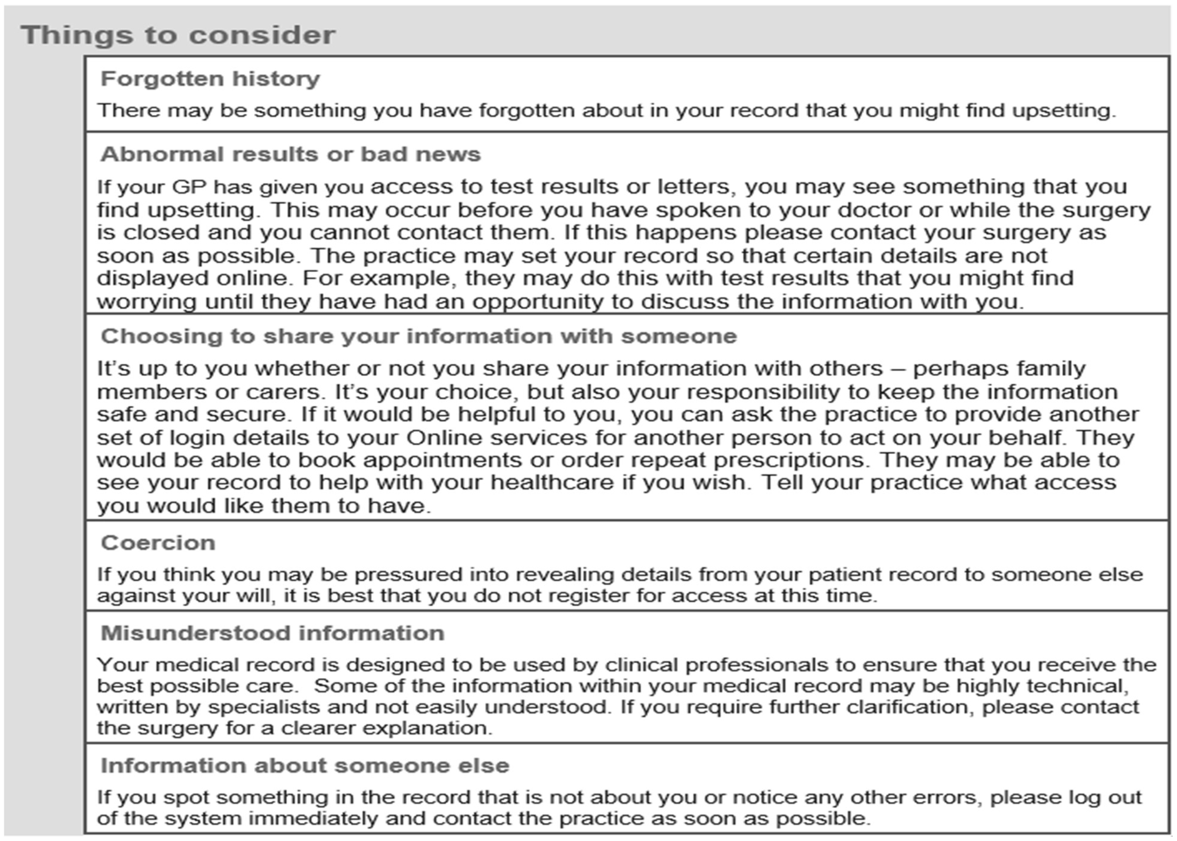
I wish to have access to the following services (please tick all that apply):
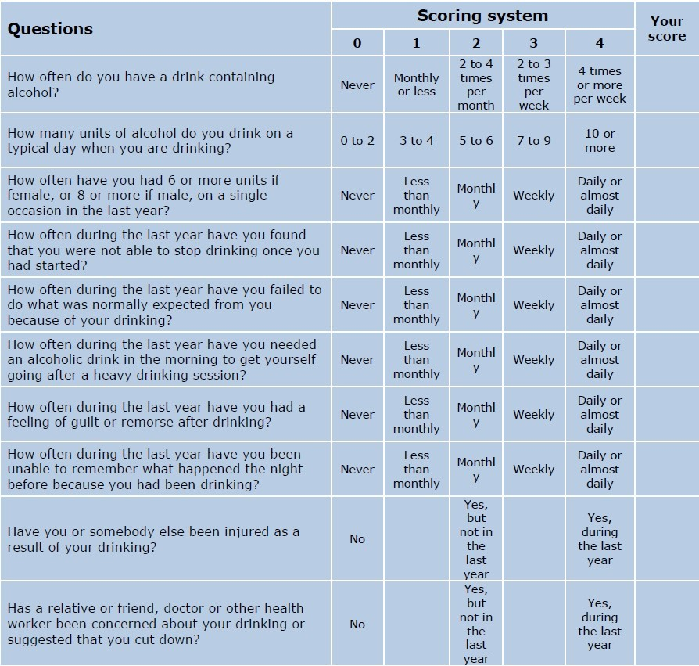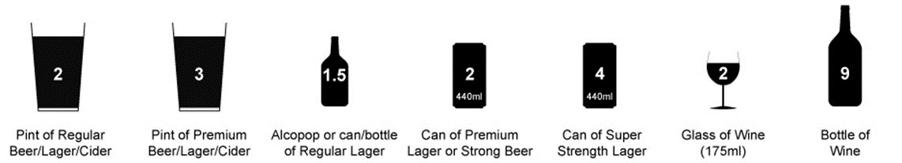
Scoring:
A total of 5+ indicates increasing or higher risk drinking. An overall total score of 5 or above is AUDIT-C positive.

If your score is higher than 8 and would like Free NHS Help for alcohol problems please call the Surgery on 01273 685588 or contact: www.changegrowlive.org.uk who offer a drop-in service at:
Richmond House,
Richmond Road,
Brighton BN2 3FT
Tel: 01273 731 900
Mon-Tues-wed-Fri 9am-5pm/Thursday 9am-7pm & Saturday 10am-1pm.

